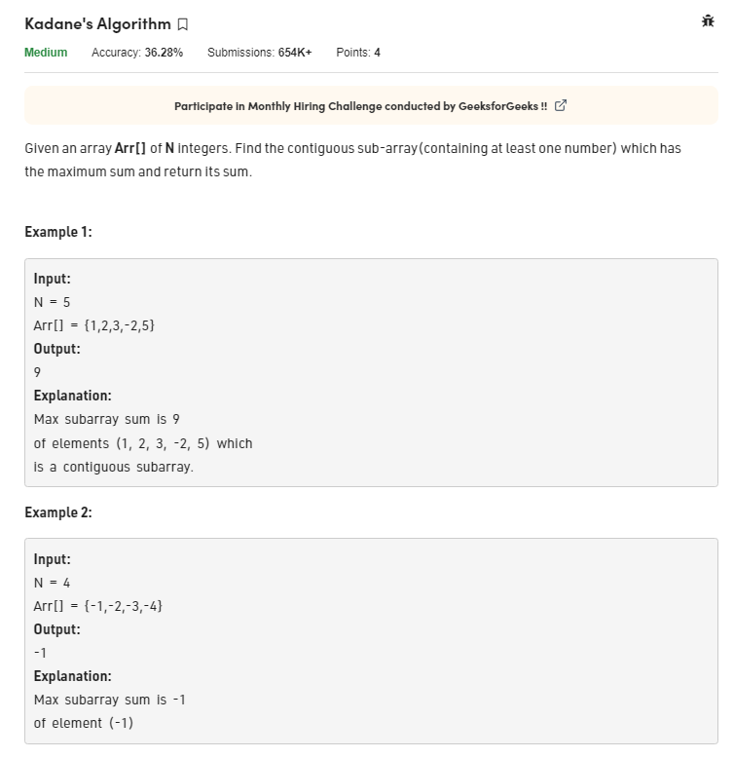class Solution{

// arr: input array

// n: size of array

//Function to find the sum of contiguous subarray with maximum sum.

long maxSubarraySum(int arr[], int n){

// Your code here

int sum=0;

int maxSum = Integer.MIN_VALUE;

for(int i=0;i<n;i++){

sum = sum + arr[i];

maxSum = Math.max(sum, maxSum);

if(sum<0){

sum=0;

}

}

return maxSum;

}

}